Cryana Tutorial

In this tutorial you can find the way to get Cryana from ParamagneticCyana2.1.
At the end of the tutorial we explain Cryana new commands.

Files
We refer to original ParagneticCyana2.1 files.

New files:
crystaldata.f
getcrydip.f

Replaced files
findzerocoords.f
psegrad.f
pseviol.f

Modified files
copy.f
cyana.for
cyanadata.f
fcn.f
grad.f
readf.f
violst.f
viosta.f

Details on modified files:
copy.f
add the subroutine:
c ==================================================================
c COPPSE: Copy pcs.
c
c Mauro und Enrico
c ------------------------------------------------------------------
subroutine coppse (i,j)
c
use cyanadata
c
implicit real(kind=selected_real_kind(12)) (a-h,o-z)
include 'pse.incl'
indxdip(j)=indxdip(i)
pshiftpse(j)=pshiftpse(i)
tolprot(j)=pshiftpse(i)
wprot(j)=wprot(i)
end

c ==================================================================

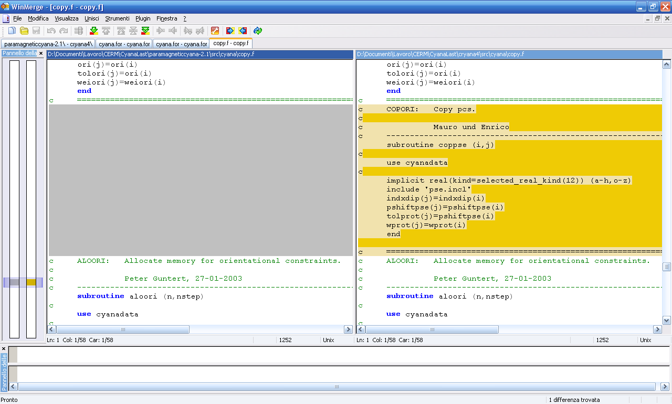

cyana.for
- add
use crystaldata

- change
cmd*100 cmd*250

- add 3 parameters
ncmd=38
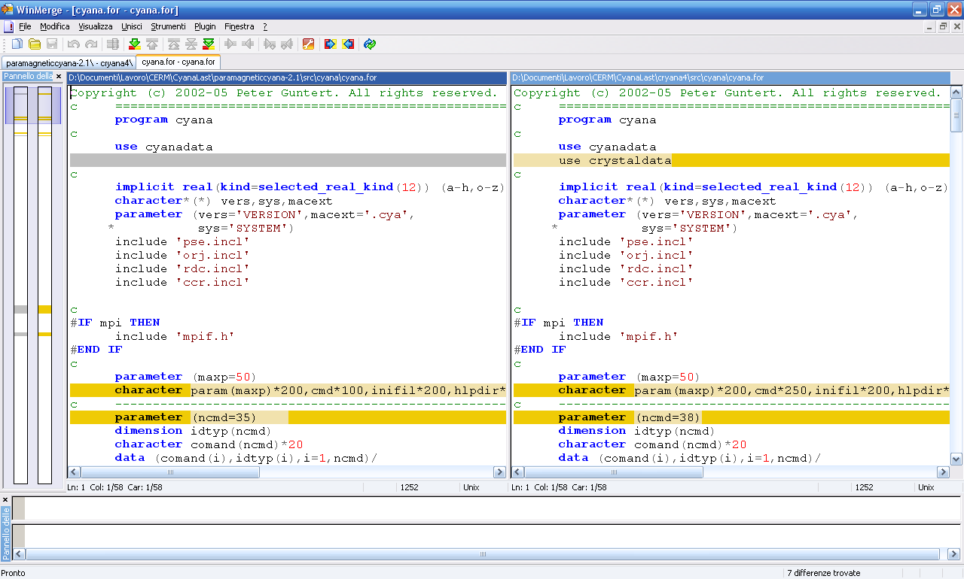

- add
'funcalc' ,0,
* 'include_cry' ,0, 'exclude_cry' ,0,

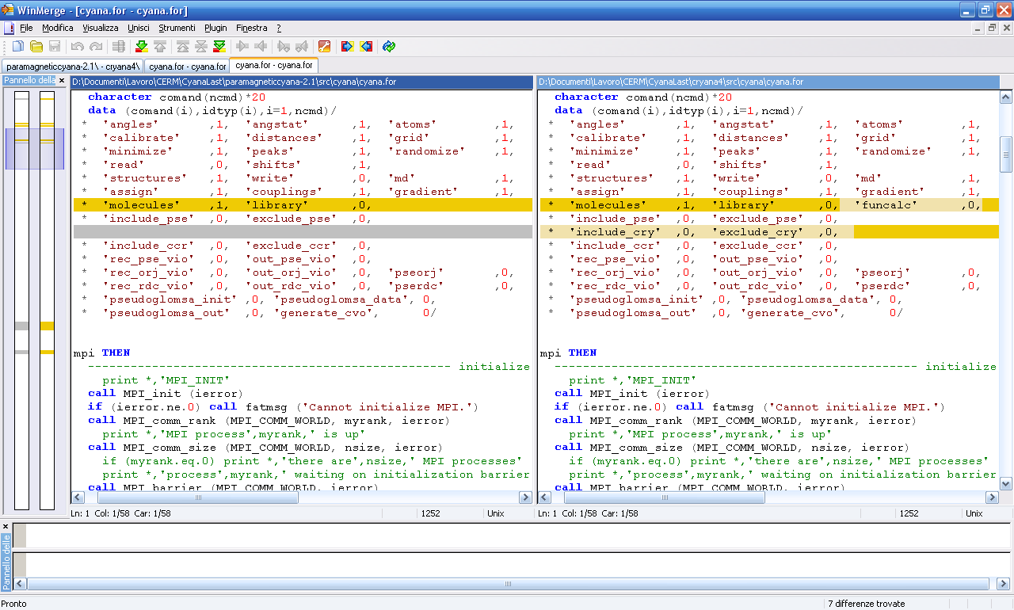

- add
case ('include_cry')
crydipflag=.true.
call putlin(2,'Pseudocontact crystal toggled ON')
case ('exclude_cry')
crydipflag=.false.
call putlin(2,'Pseudocontact crystal toggled OFF')

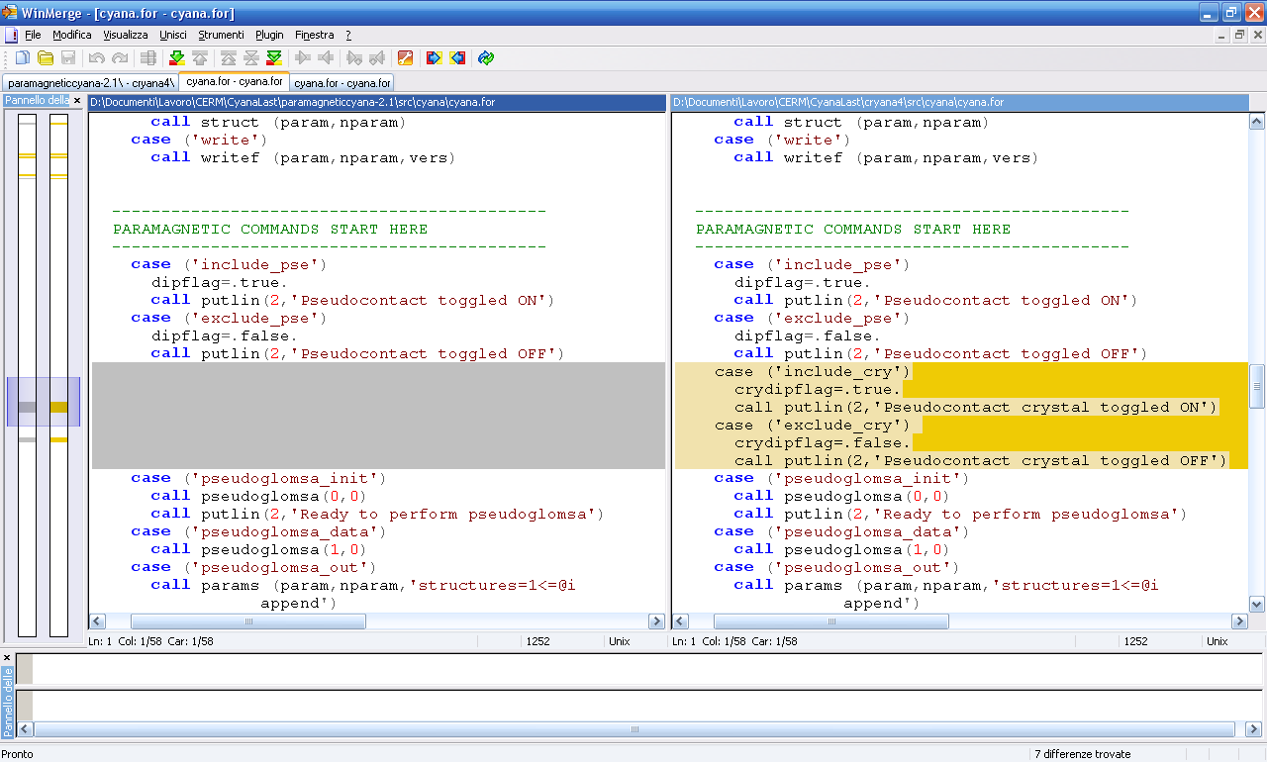

- add
case ('funcalc')
call inifcn(2)
call fcn(perso)

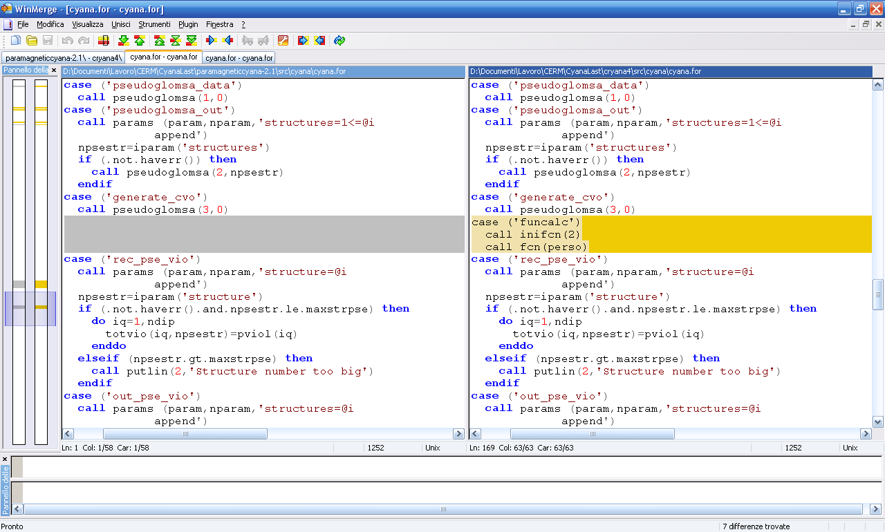
cyanadata.f
- change
nctyp=6 nctyp=7

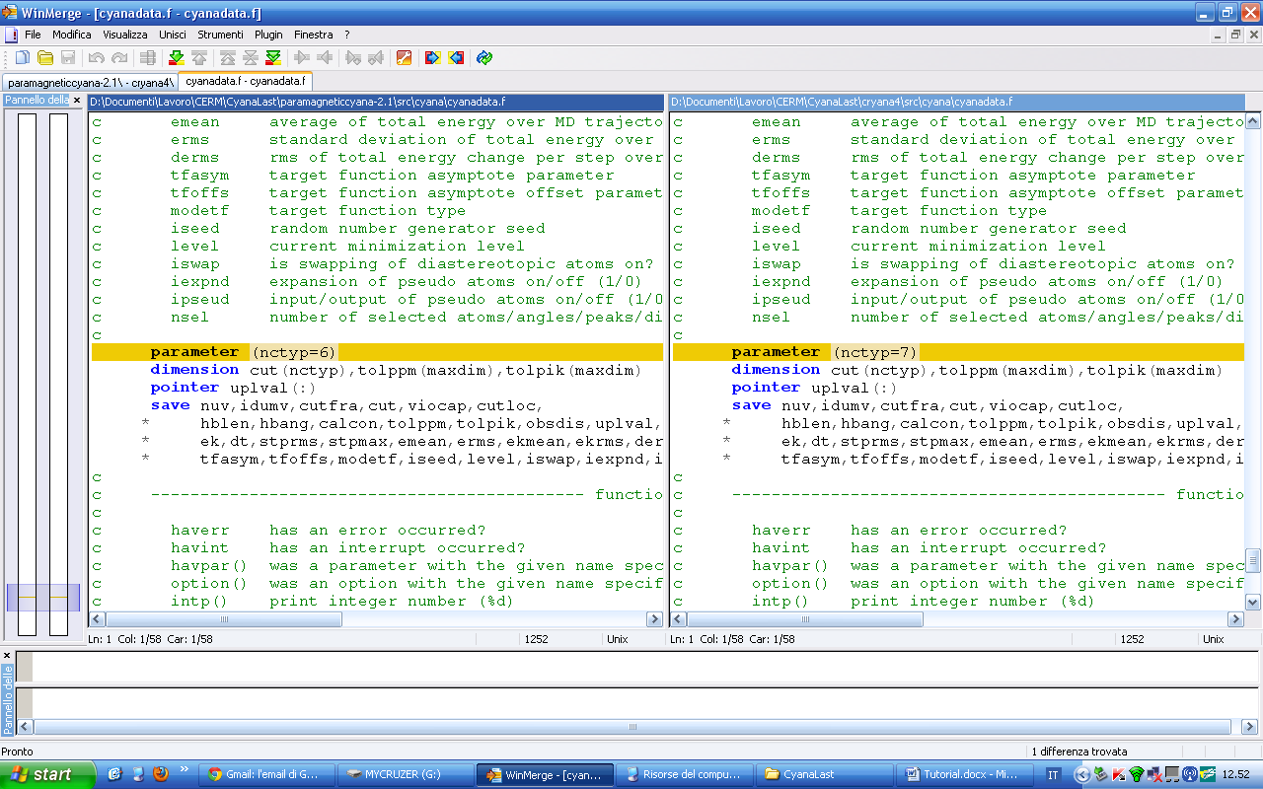

fcn.f
- add
use crystaldata

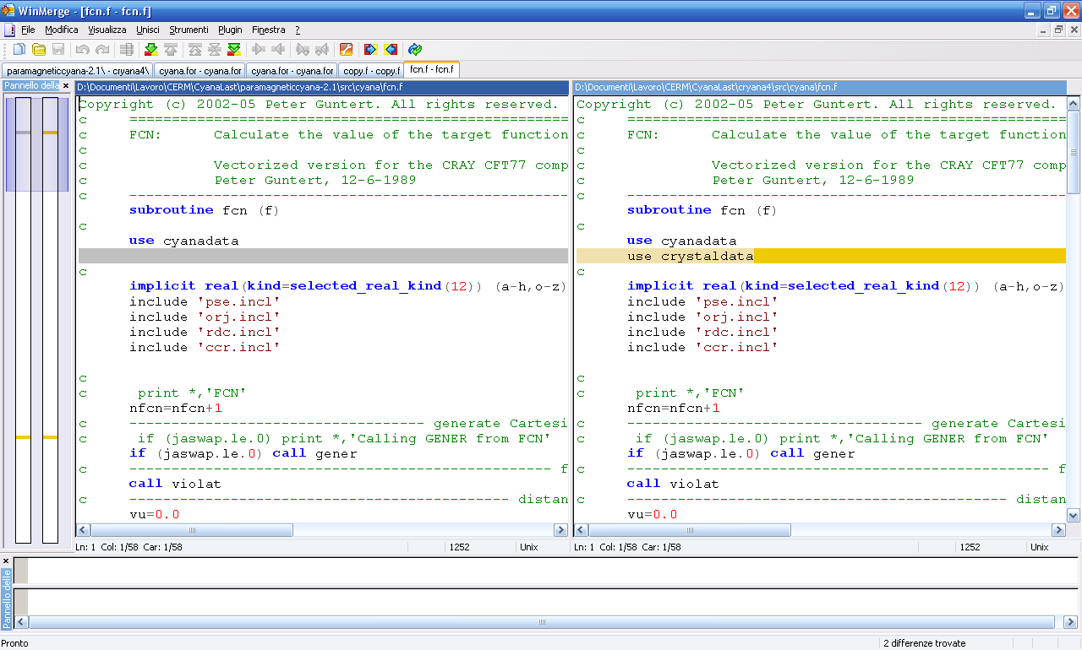
- change
if (dipflag) f=f+wdip*pseviol() if (dipflag.or.crydipflag) f=f+pseviol()

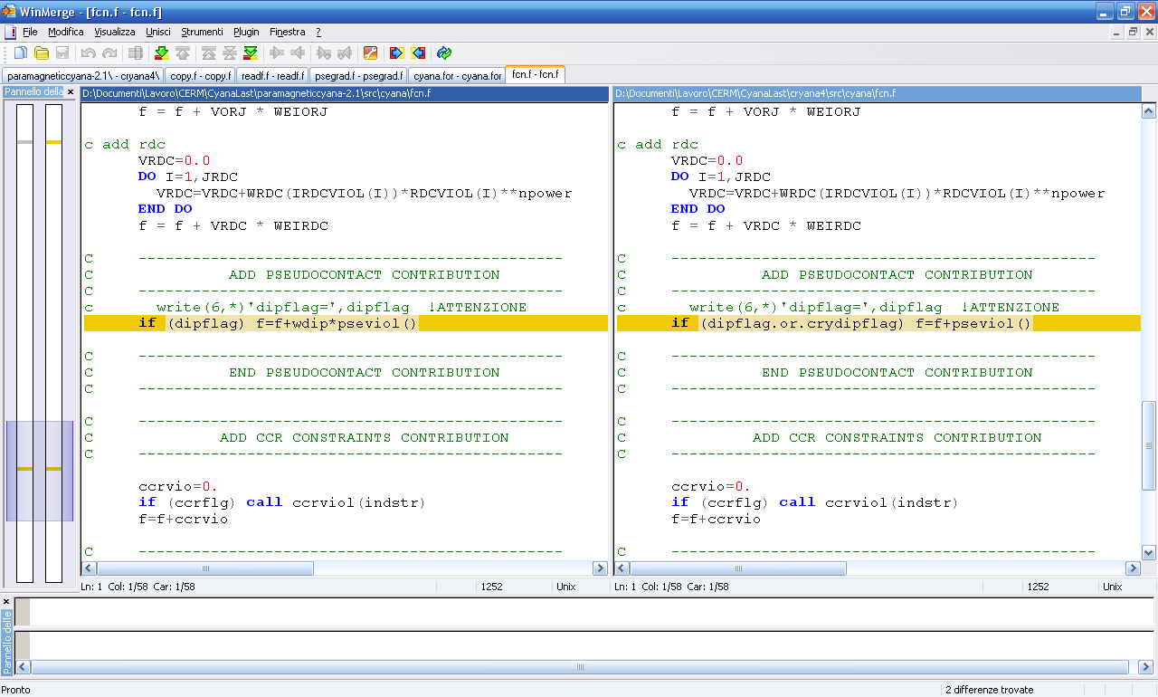

grad.f
- add
use crystaldata

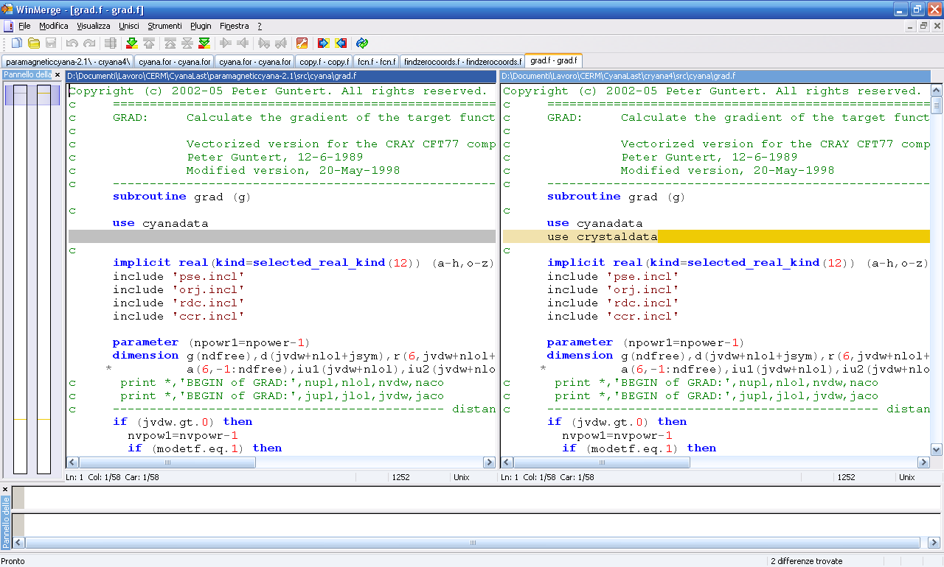

- change
if (dipflag) call psegrad(ndfree,g) if (dipflag.or.crydipflag) call psegrad(ndfree,g)

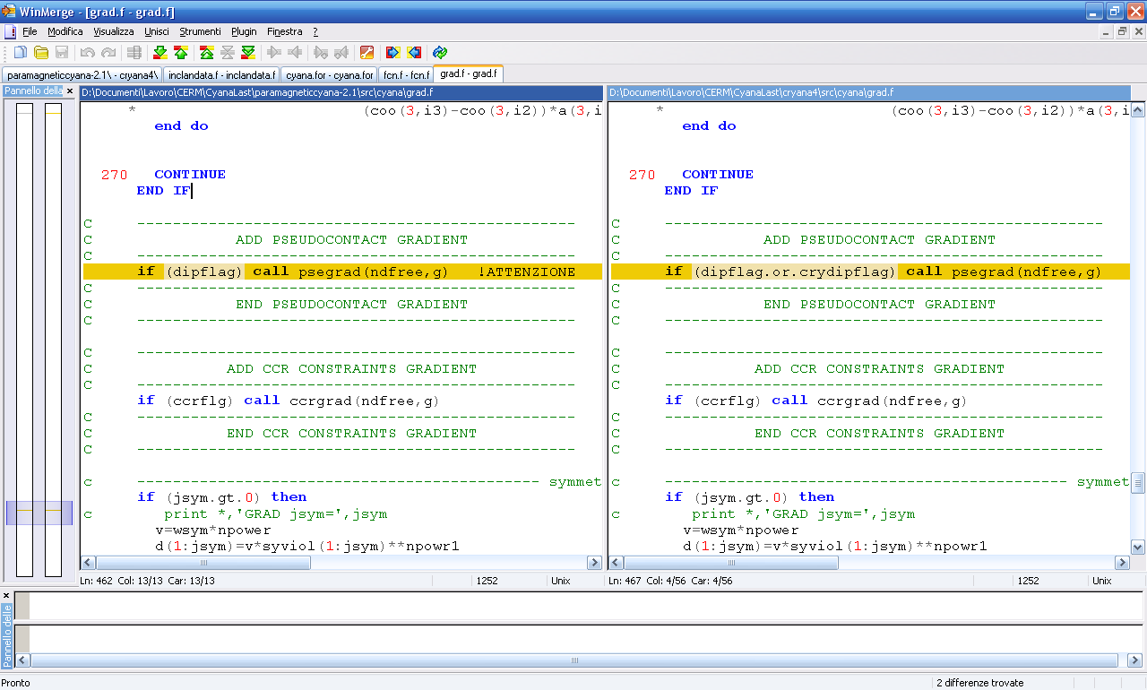

readf.f
- add
use crystaldata

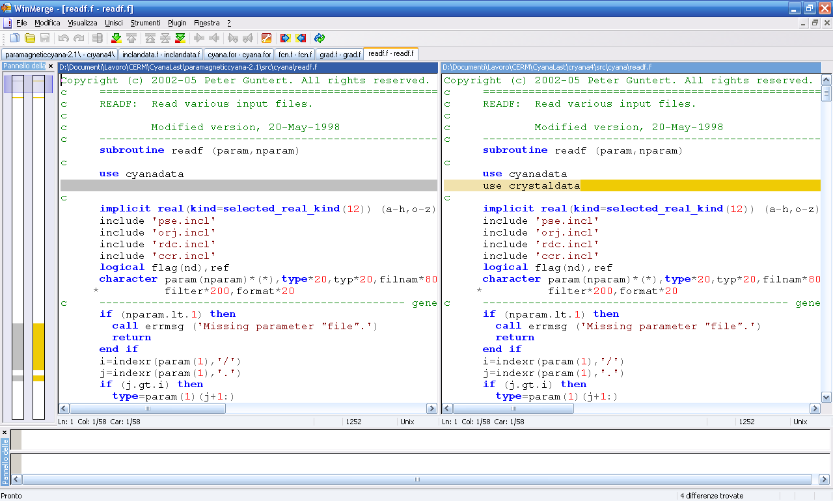

- add omr and cry
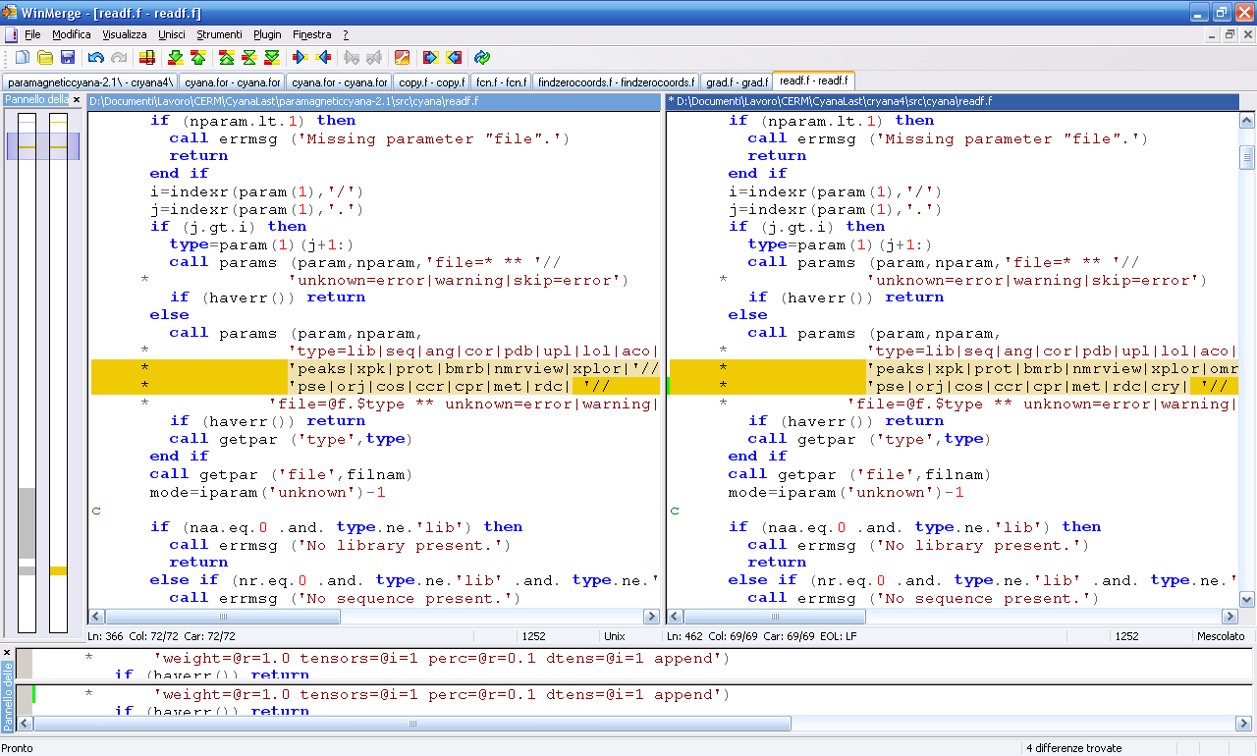

- add cry case
c ------------------------------------------------ pseudo
case ('cry')
call params (param,nparam,'tolerance=@r=0.4 crystal=@i=1 '//
* 'weight=@r=1.0 tensors=@i=1 perc=@r=0.1 dtens=@i=1 '//
* 'OMweight=@r=10.0 OMtol=@r=0.1 '//
* 'celldimx=@r=0.0 celldimy=@r=0.0 celldimz=@r=0.0 '//
* 'symmetry=none|P21212|P212121|P222|P2221|=none append')
if (haverr()) return
OMflag=.false.
crytoldip=rparam('tolerance')
cryncrystal=iparam('crystal')
crywdip=rparam('weight')
cryntenso=iparam('tensors')
crypseperc=rparam('perc')
cryNDTENSO=iparam('dtens')
cellDim(1)=rparam('celldimx')
cellDim(2)=rparam('celldimy')
cellDim(3)=rparam('celldimz')
call getpar ('symmetry',symmetry)
crystalmode=cryncrystal
if (cellDim(1).eq.0.0.or.cellDim(2).eq.0.0.or.cellDim(3).eq.0.0)
* then
CALL ERRMSG('Please insert crystal cell dimensions '//
* 'celldimx, celldimy, celldimz')
stop
end if
select case (cryncrystal)
case (0)
SolidState=.false.
case (1)
SolidState=.true.
call putlin (2,'Crystal mode')
!inizializzazione matrici di rotazione per pcs con stato solido
call initRotMatrix
case (2)
SolidState=.true.
OMflag=.true.
OMweight = rparam('OMweight')
OMtol = rparam('OMtol')
call putlin (2,'Crystal mode with origin '//
* 'forced alignment with internal metal')
call putlin (2,'Do not forget to upload a matrix '//
* 'by a .omr file')
call initRotMatrix

case default
CALL ERRMSG('wrong crystal mode! select 0 or 1')
end select
if (cryNDTENSO.ne.1.and.cryntenso.ne.1) then
write(6,*) 'OPTION NOT YET IMPLEMENTED'
stop
end if
if (cryNDTENSO*cryntenso.gt.maxtenscry/2) then
CALL ERRMSG('Too many tensors!')
stop
endif
if (.not.option('append')) ndipcry=0
n=ndipcry
call getcrydip(1,mode)
close(1)
if (haverr()) go to 900
call putlin (2,'Pseudo contact shifts constraint '//
* 'file '//strq(filnam)//
* ' read, '//plural(ndipcry-n,'constraint')//'.')

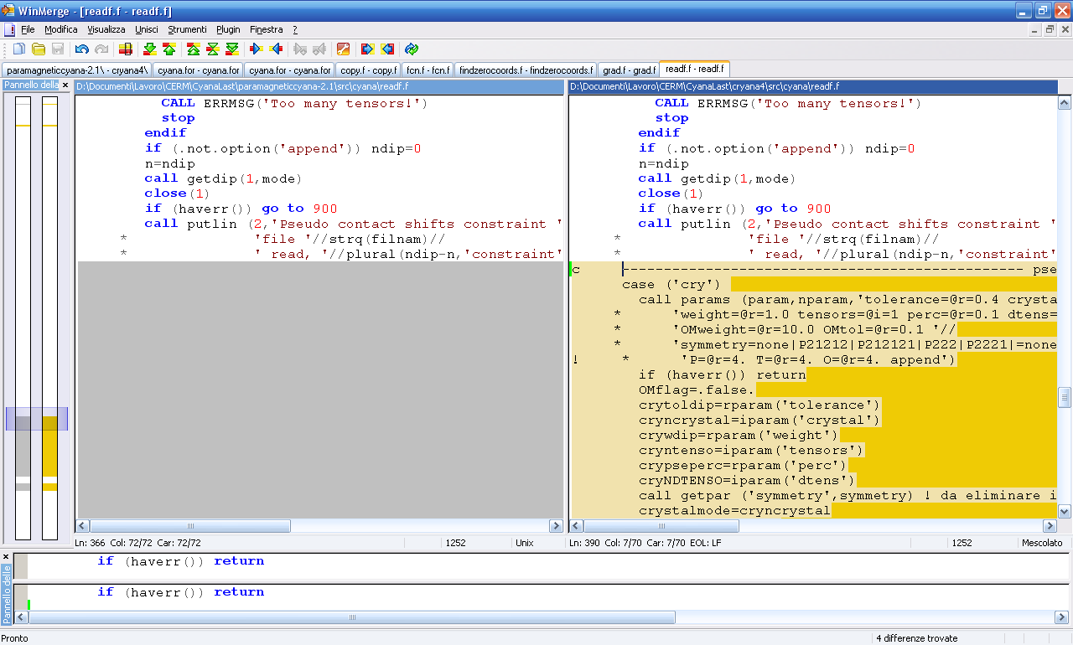

- add omr case
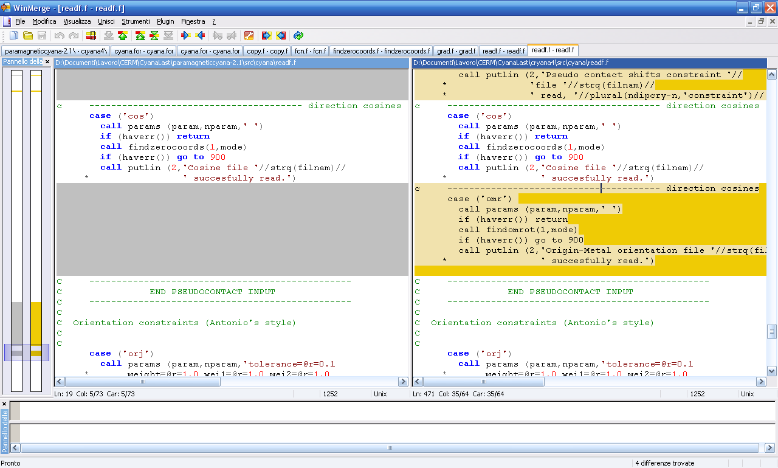

violst.f
- add

include ‘pse.incl’

- add variables
vpse(ndip,nscor),indpse(ndip),keypse(ndip),vipse(ndip)

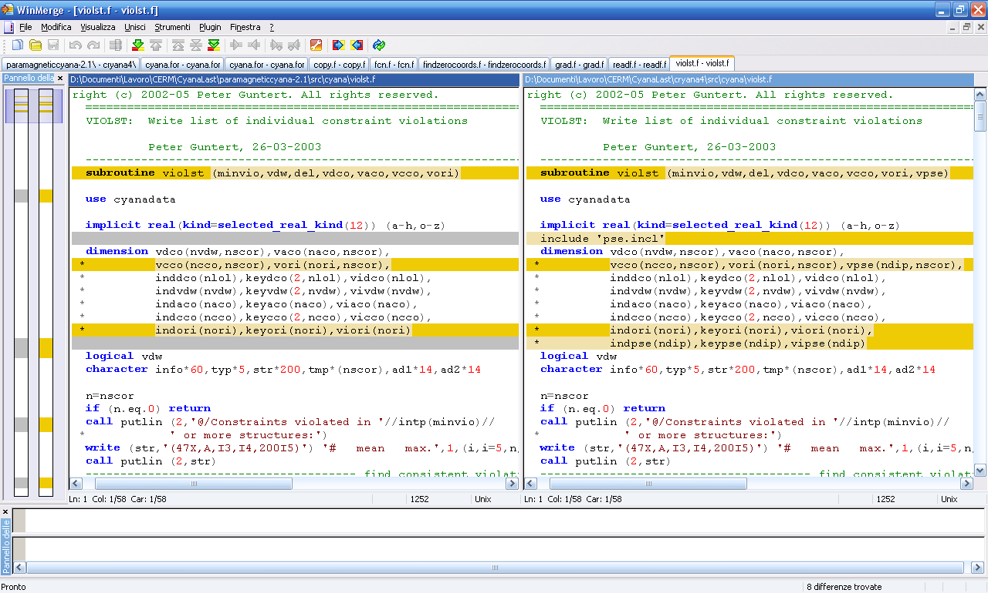

- add
nvpse=0
cut(7)=toldip
do i=1,ndip
nvio=count((vpse(i,1:n).gt.cut(7)))
if (count((vpse(i,1:n).gt.cut(7))).ge.minvio) then
nvpse=nvpse+1
indpse(nvpse)=i
keypse(nvpse)=indxdip(i)
end if
end do
call isort (keypse,indpse,nvpse,1)

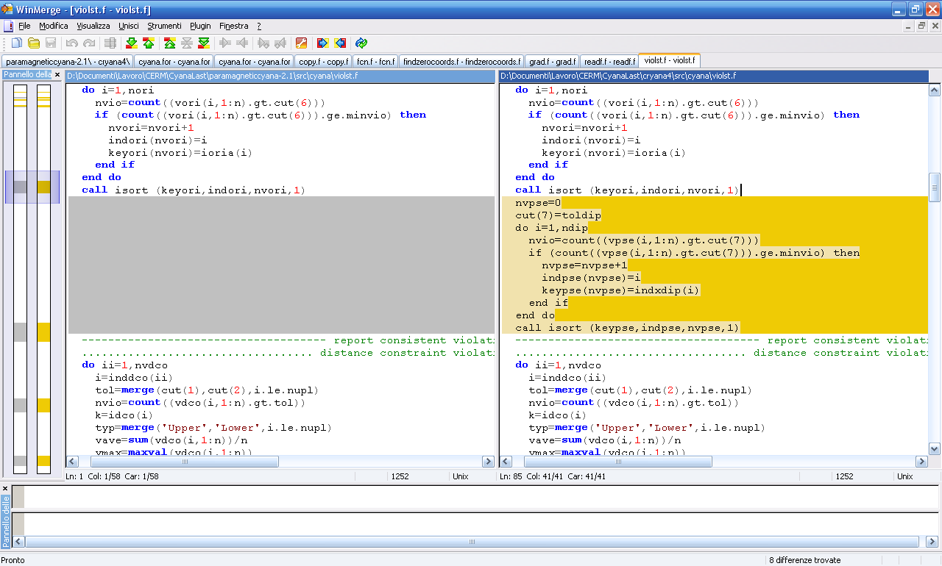

- add
c ................................... pseudocontact shift violations
do ii=1,nvpse
i=indpse(ii)
nvio=count((vpse(i,1:n).gt.cut(7)))
vave=sum(vpse(i,1:n))/n
vmax=maxval(vpse(i,1:n))
vipse(ii)=vave
tmp=' '
do j=1,n
if (vpse(i,j).gt.cut(7))
* tmp(j:j)=merge('*','+',vpse(i,j).eq.vmax)
end do
ad1=adescr(indxdip(i))
call putlin (2,'Pcs '//strp(ad1)//realf(pshiftpse(i),16,2)//
* realf(tolprot(i),8,2)//intn(nvio,4)//
* realf(vave,7,2)//realf(vmax,7,2)//' '//strp(tmp))
end do
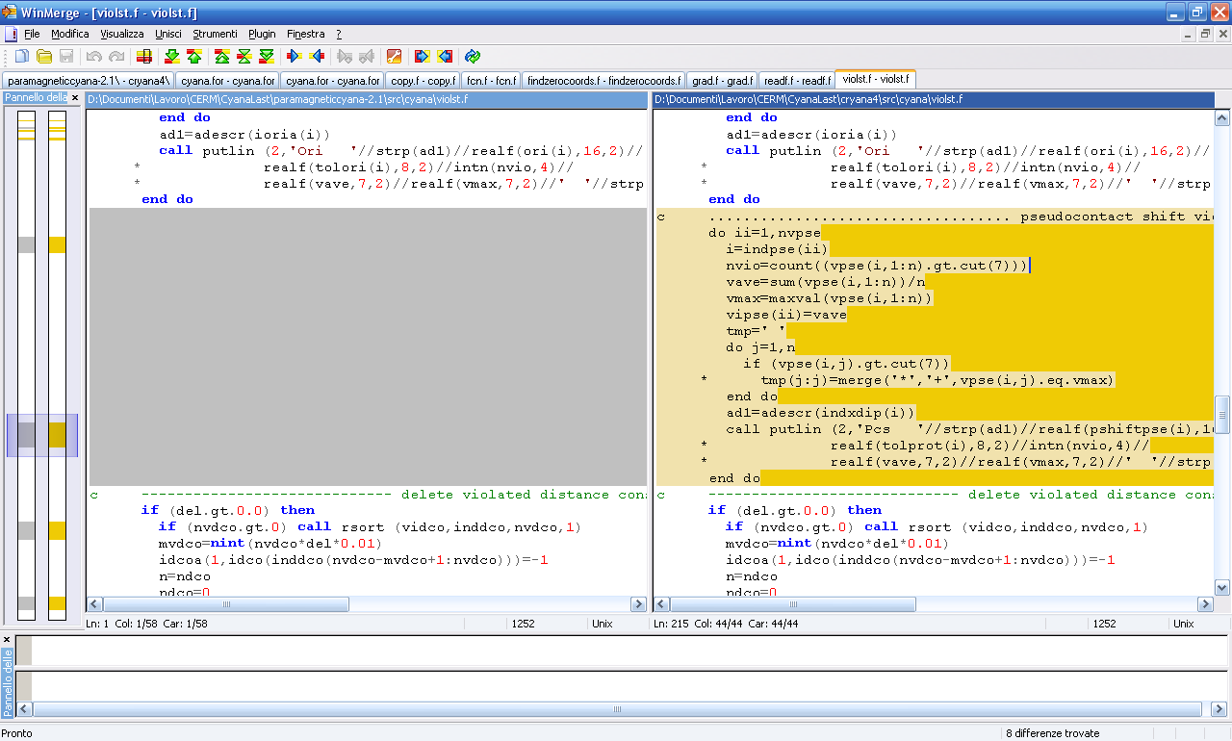

- add
c ------------------------ delete pseudocontact shifts constraints
if (nvpse.gt.0) call rsort (vipse,indpse,nvpse,1)
mvpse=nint(nvpse*del*0.01)
indxdip(indpse(nvpse-mvpse+1:nvpse))=-1
n=npse
npse=0
do i=1,n
if (indxdip(i).gt.0) then
npse=npse+1
call coppse (i,ndip)
end if
end do
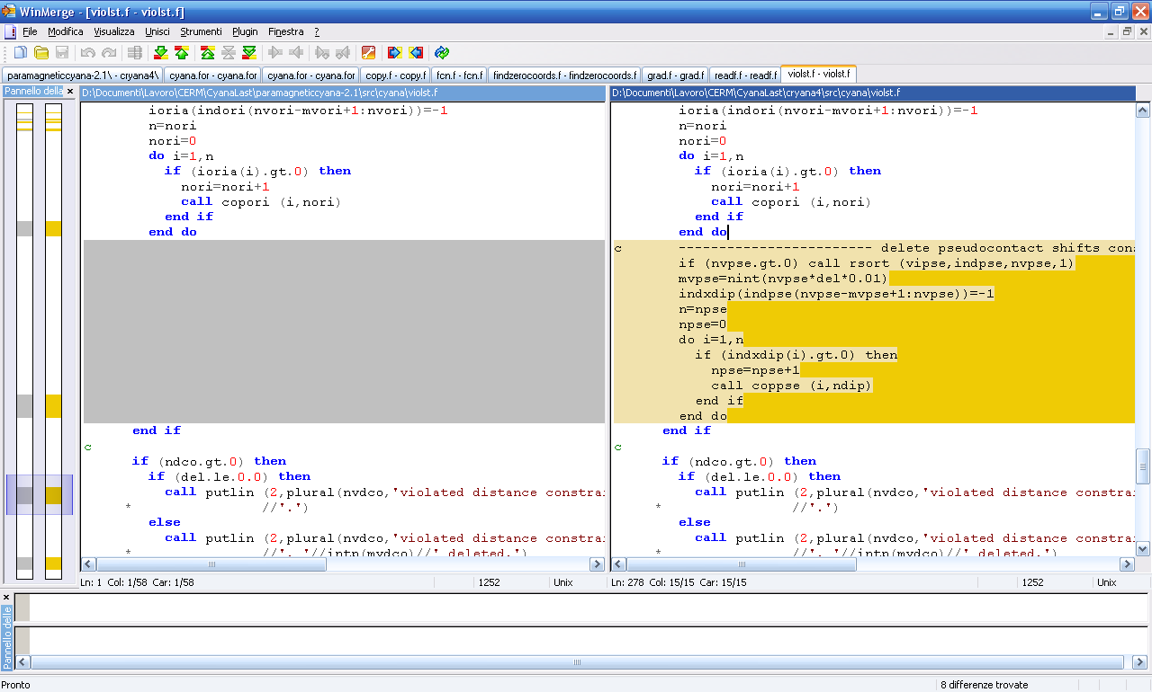

- add
if (ndip.gt.0) then
if (del.le.0.0) then
call putlin (2,plural(nvpse,'violated pcs '//
* 'constraint')//'.')
else
call putlin (2,plural(nvpse,'violated pcs '//
* 'constraint')//', '//intp(mvpse)//' deleted.')
end if
end if

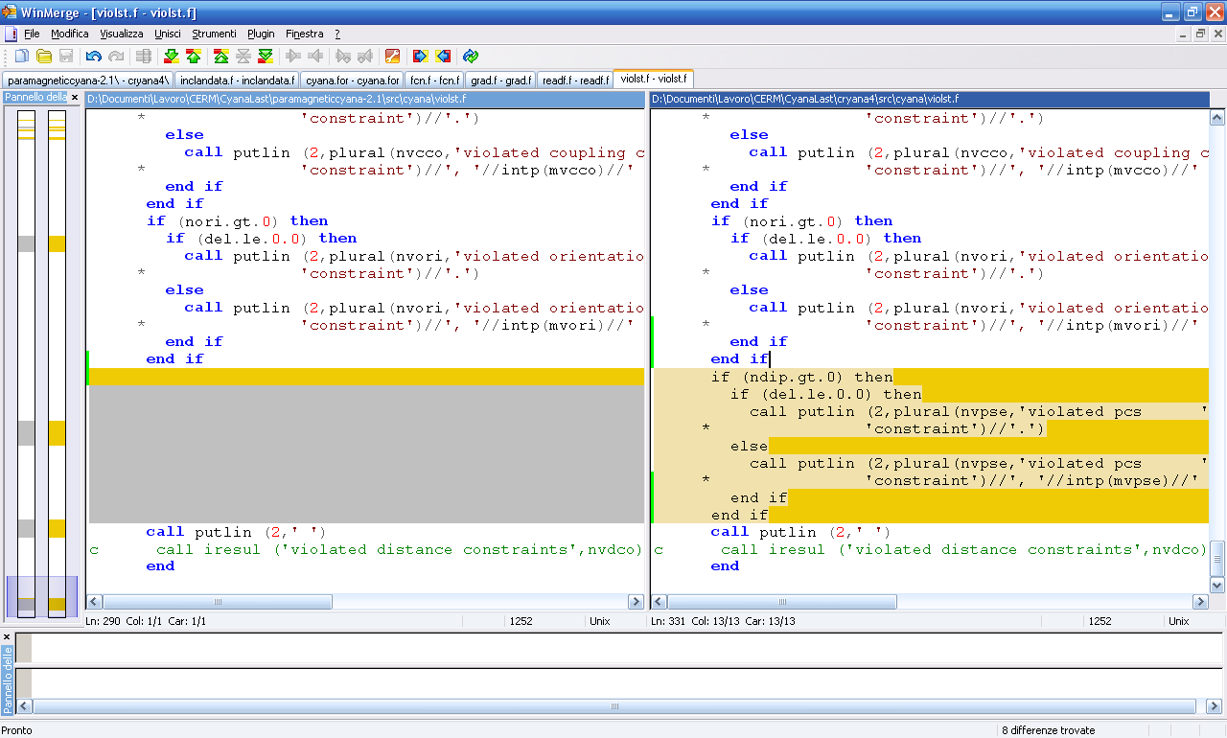

viosta.f
- add

include ‘pse.incl’

- add variables
vpse(:,:),

- change
ncon(1:nctyp)=max((/nupl,nlol-nupl,1,naco1,ncco,nori/),

ncon(1:nctyp)=max((/nupl,nlol-nupl,1,naco1,ncco,nori,ndip/),

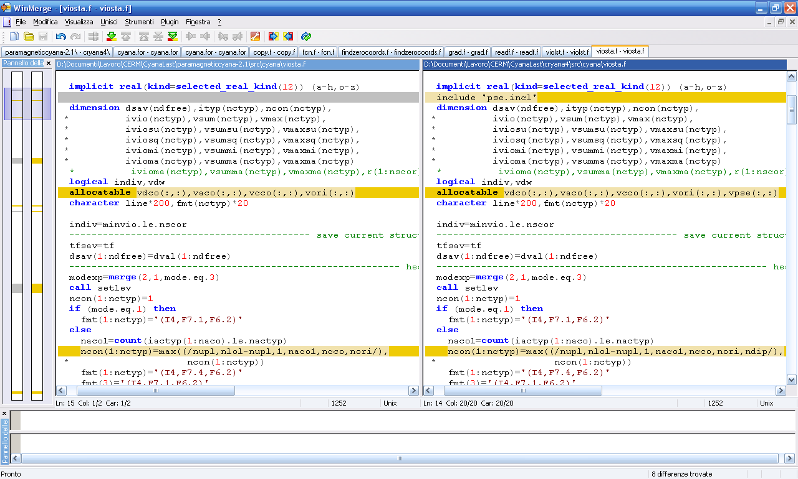

- add
if (ndip.gt.0) then
ntyp=ntyp+1
ityp(ntyp)=7
line(len_trim(line)+1:)=' pc shifts'
end if
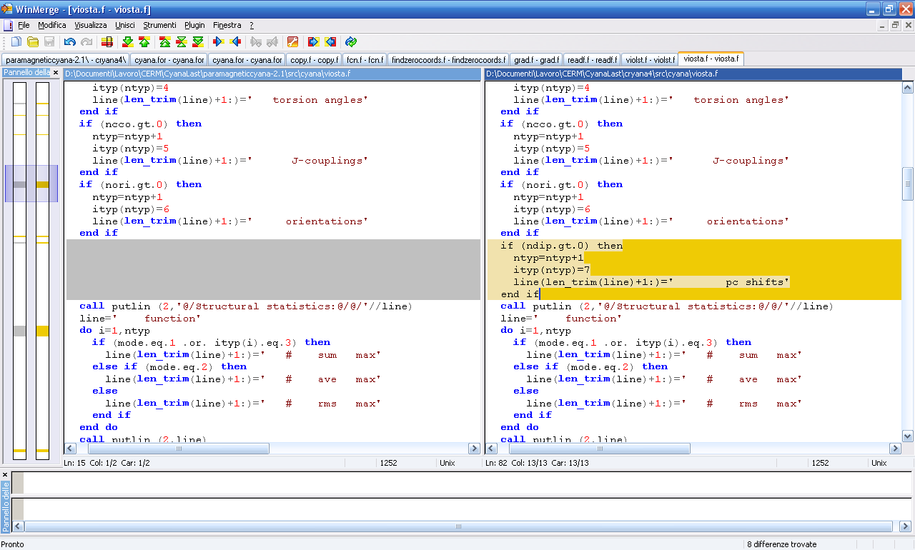

- change
allocate (vdco(nvdw,nscor),vaco(naco,nscor),
* vcco(ncco,nscor),vori(nori,nscor))

allocate (vdco(nvdw,nscor),vaco(naco,nscor),
* vcco(ncco,nscor),vori(nori,nscor),vpse(ndip,nscor))

- add
vpse(1:ndip,1:nscor)=0.0

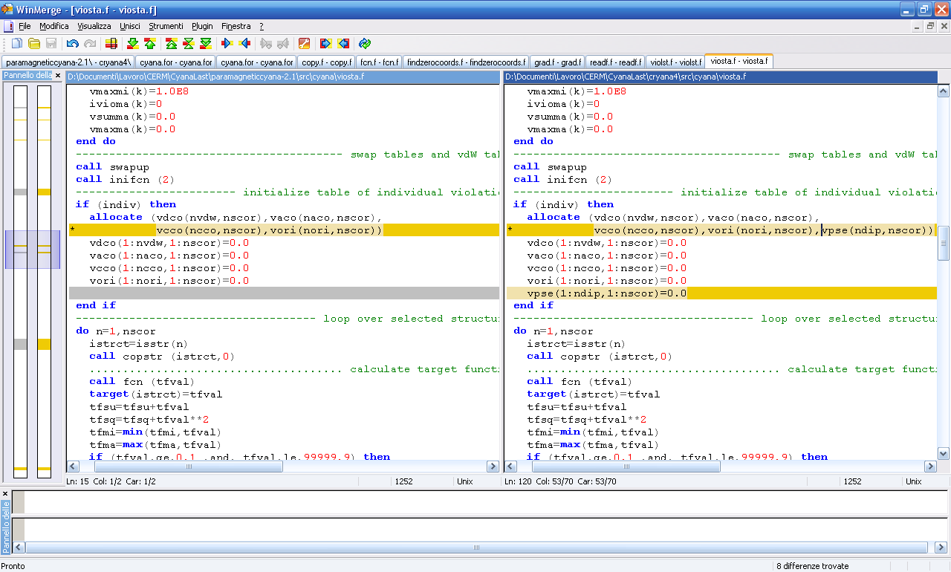
- add
k=7
do i=1,ndip ! jpsevio. ora glieli facciamo scrivere tutti
v=abs(pviol(i))
if (indiv) vpse(i,n)=v ! vpse(ioviol(i),n)=v
if (v.gt.cut(k)) ivio(k)=ivio(k)+1
vsum(k)=vsum(k)+v**modexp
vmax(k)=max(vmax(k),v)
end do

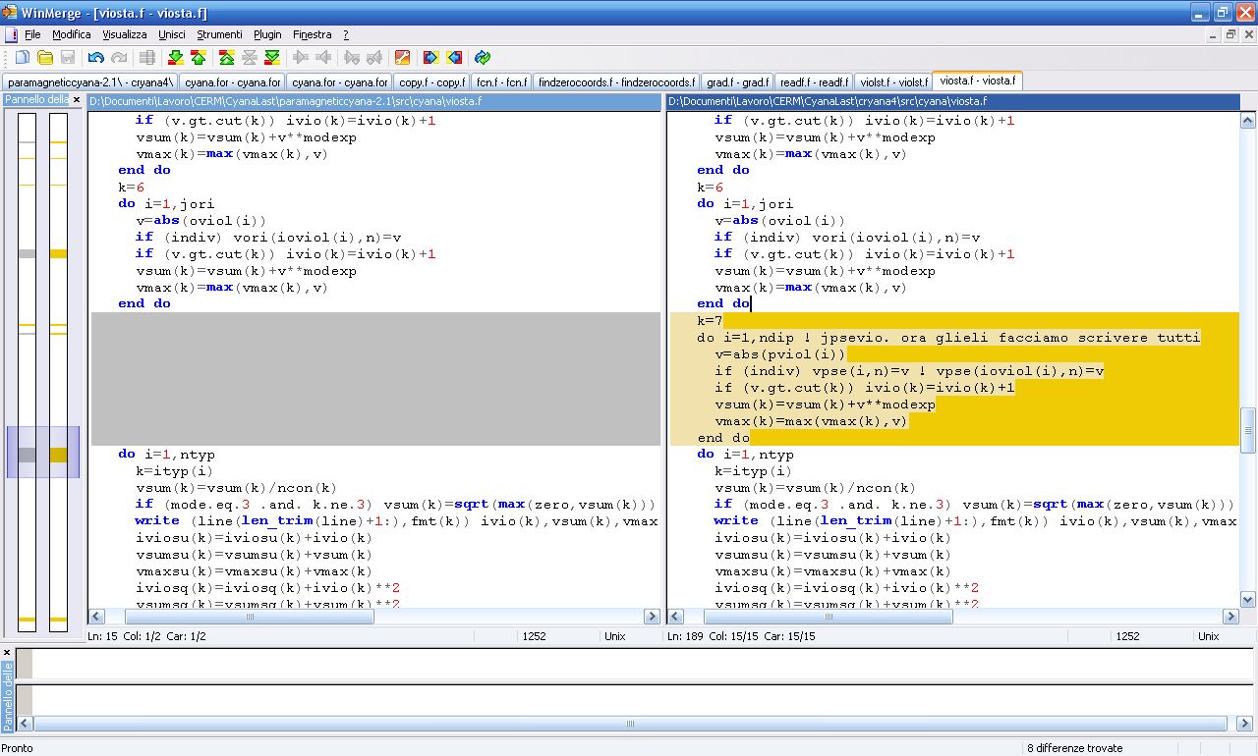

- change
call violst (minvio,vdw,del,vdco,vaco,vcco,vori)
deallocate (vdco,vaco,vcco,vori)

call violst (minvio,vdw,del,vdco,vaco,vcco,vori,vpse)
deallocate (vdco,vaco,vcco,vori,vpse)

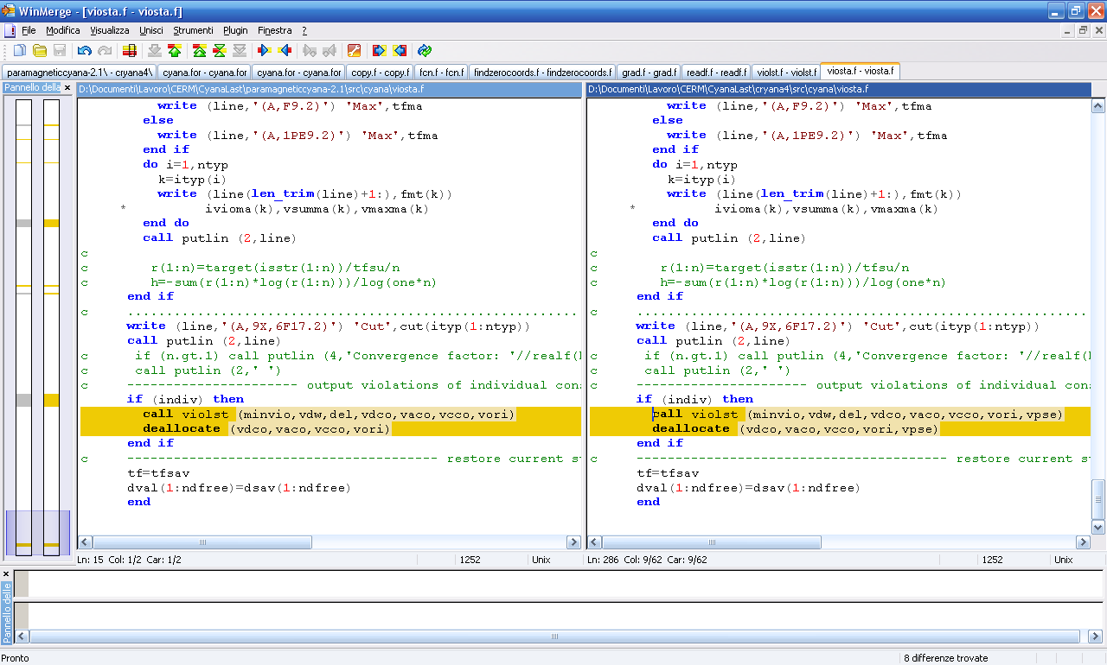

pse.incl
- change
MAXDIP=2500 MAXDIP=10000

- add variable jpsevio
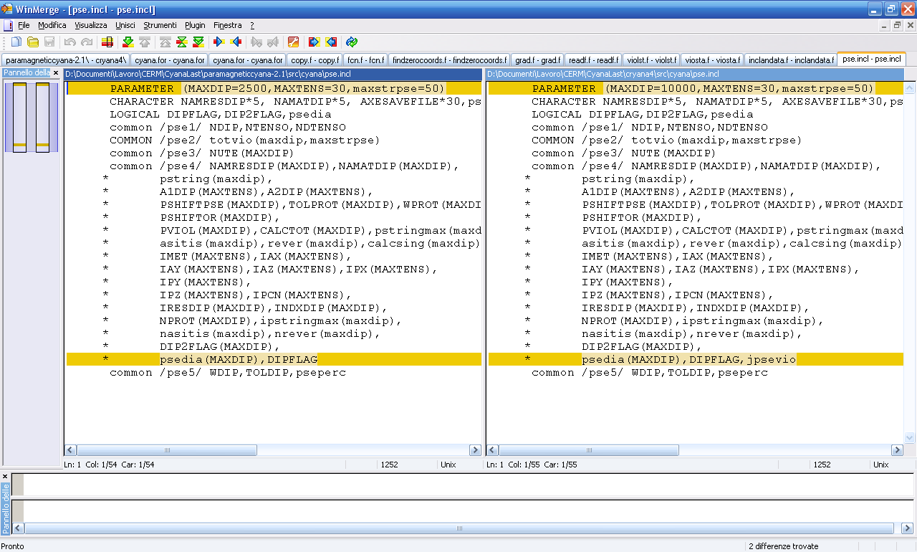

Commands
This section reviews syntax and parameters of the new commands introduced.
To read a pse file that is being used considering the contribution to pcs of external symmetric metals, a typical command is the following:
read cry observed_pcs.pse tensors=2 weight=0.5 tolerance=0.2 perc=0.2 symmetry=P21212 ↵
celldimx=69.194 celldimy=62.564 celldimz=37.262
read cos anisoTensor.cos

Reading the cry file, tensors is the number of tensors present in the sequence, including the crystal origin tensor, and they must be specified at the end of the pse file (the origin have to be the last tensor in pse file).
The symmetry allowed at the moment are P222, P222₁, P2₁2₁2, P2₁2₁2₁ .
celldimx, celldimy and celldimz are the dimensions of the asymmetric unit cell.
The meaning of other parameters is obvious.
The cos file is the file containing the information of susceptibility magnetic tensor.

If we need to fix a specific orientation for the origin with respect to the metal tensor orientation we can use the following command:
read cry observed_pcs.pse tensors=2 weight=0.5 tolerance=0.2 perc=0.2 symmetry=P21212 ↵
celldimx=69.194 celldimy=62.564 celldimz=37.262 crystal=2 OMweight=100.0
read cos anisoTensor.cos
read omr XY.omr

The parameter crystal=2 (default is crystal=1) means that an omr file needs to be read to restrain the reciprocal orientation of the two tensors. The omr file is just a file containing a matrix. If M is the matrix containing in rows the coordinates of the unit vectors AX, AY and AZ defining the metal tensor orientations and O is the matrix containing in rows the coordinates of the unit vectors defining crystallographic origin orientations, the omr file contains the matrix M^{T}O.

Other useful added commands are:
include_cry
exclude_cry
to include/exclude the contribution of the global pcs restraints in the calculation of the TF.

An example of pse file
155 GLN C 0.30 1 0.20 1.50 1
155 GLN CA 0.52 1 0.20 1.50 1
155 GLN CB 0.30 1 0.20 1.50 1
155 GLN CG 0.31 1 0.20 1.50 1
155 GLN CD 0.24 1 0.20 1.50 1
156 SER C 0.39 1 0.20 1.50 1
156 SER CA 0.52 1 0.20 1.50 1
156 SER CB 0.15 1 0.20 1.50 1
157 LEU C 0.56 1 0.20 1.50 1
157 LEU CA 0.58 1 0.20 1.50 1
157 LEU CB 0.81 1 0.20 1.50 1
157 LEU CG 0.52 1 0.20 1.50 1
200 LTNS ME
40 LTNS ME

An example of cos file
1.00000E+00 0.00000E+00 0.00000E+00
0.00000E+00 1.00000E+00 0.00000E+00
0.00000E+00 0.00000E+00 1.00000E+00
7.00370E-32 -2.33456E-32

The last two numbers of cos file are the axial and rhombic components of the susceptibility anisotropy tensor.

An example of omr file
0.78169E+00 -0.39277E+00 0.48486E+00
-0.55380E+00 -7.92354E-02 0.82870E+00
-0.28648E+00 -0.91584E+00 -0.28045E+00

